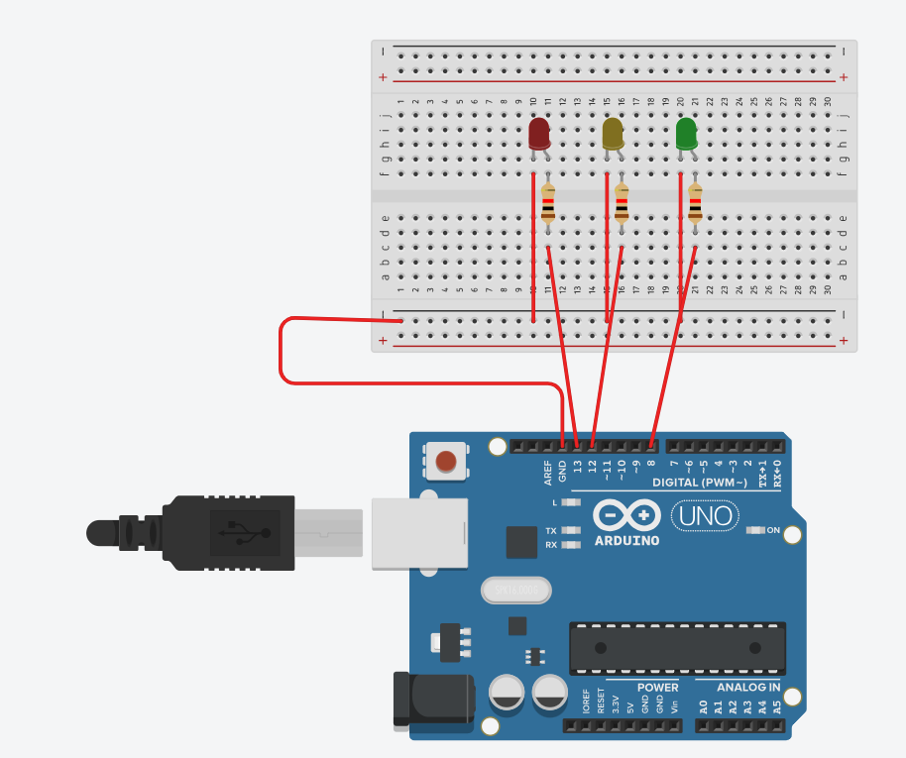
void setup() {
pinMode(13, OUTPUT); // Red LED
pinMode(12, OUTPUT); // Yellow LED
pinMode(8, OUTPUT); // Green LED}
void loop() {
// Green light on for 5 seconds
digitalWrite(8, HIGH);
delay(5000);
digitalWrite(8, LOW);
// Yellow light on for 2 seconds
digitalWrite(12, HIGH);
delay(2000);
digitalWrite(12, LOW);
// Red light on for 5 seconds
digitalWrite(13, HIGH);
delay(5000);
digitalWrite(13, LOW);}

